**Document (Technical Details for Proposed Robot)**

1. **Type of Robot:** **Application Based Fire Fighting Robot**.
2. **Robot Assembly Design (Proposed Diagram): Drawings each part of the robot is preferred as an attachment. (CAD drawings are preferred).**

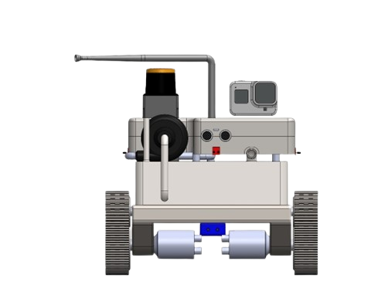

**Figure 1 Front View**

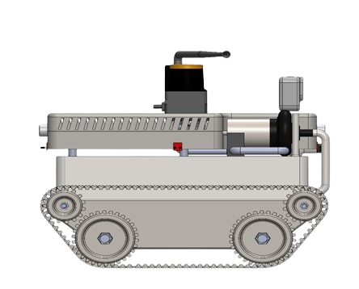

**Figure 2 Side View**

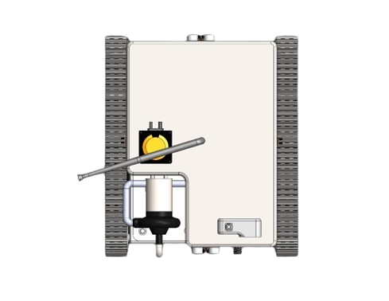

**Figure 3 Top View**

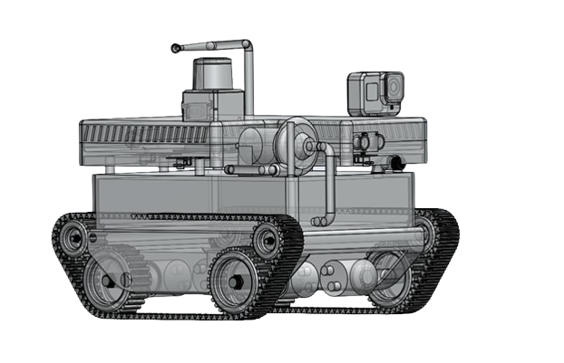

**Figure 4 Proposed Model**

1. **Components to be used: Enlist all the components with their make/company in four groups as enlisted in the following**
2. **List of Structure components:**

|  |  |
| --- | --- |
| Aluminum Alloy Sheet | Metal Driving Wheel |
| DC Encoder Motor | Shock Absorbing Plastic Belt |
| Wire | PCB |
| Nut and Bolt |  |

1. **List of Motion Components:**

|  |  |
| --- | --- |
| DC Encoder Motor | Motor Controller |
| Plastic Bearing Wheels | LiPo Batteries |

1. **List of electronics components:**

|  |  |
| --- | --- |
| Temperature Sensors - LM35 | Thermal Camera - mlx906460 |
| Ultrasonic Sensor (For Distance) | IR Sensor / Flame Sensor – KY026 |
| Lidar Sensor - YDLIDAR X4 | MQ-2 Sensor (For Gas) |
| Raspberry Pi / Google Coral / Nvidia Jetson Nano | Camera - Raspberry Pi Camera Module 2 |
| Power Supply / Battery | Motors - 25mm DC Brush Motor |
| Ardunio / ESP32 | Pump - Crompton CHAMP PLUS II Centrifugal |
| Water Pump (0.5 hp) | Adapter - Micro USB |

1. **The Methodology of Making Robot:**

**Problem Statement:**

* Design an autonomous robot capable of extinguishing fire in various environments.

**Objectives:**

* Develop a robot capable of detecting and locating fire autonomously.
* Design a mechanism for the robot to extinguish fire effectively without human intervention.
* Implement safety features to ensure the robot's stability and reliability during fire-fighting operations.

**Introduction:**

* An autonomous fire-fighting robot is a specialized machine designed to detect, locate, and extinguish fire without human intervention. It combines sensors, actuators, and intelligent algorithms to navigate environments and perform fire-fighting tasks efficiently.

**System Modelling:**

* The fire-fighting robot's design is based on a modular system comprising the following key components:

1. **Fire Detection and Localization System:** Incorporate sensors such as thermal cameras, smoke detectors, and infrared sensors to detect fire and determine its precise location.
2. **Extinguishing Mechanism:** Develop a mechanism to extinguish fire, which may include water spraying systems, foam dispensers, or dry chemical agents.
3. **Autonomous Navigation:** Implement slam algorithms for autonomous navigation, obstacle avoidance, and path planning to enable the robot to move effectively in dynamic environments.
4. **Safety and Stability Control:** Integrate safety features such as emergency stop buttons, and stability control algorithms to ensure the robot's safe operation during fire-fighting tasks.

**Hardware Specifications:**

* Microcontroller or Single Board Computer (e.g., Raspberry Pi) and GPU (e.g., Nvidia Jetson / Google Coral) for processing and control.
* Sensors: Thermal cameras, smoke detectors, flame sensors.
* Actuators: Water spraying systems, foam dispensers, motorized wheels, or tracks for movement.
* Communication Module: Wi-Fi or Bluetooth for remote control and data transmission.
* Power System: Rechargeable batteries or power management system for continuous operation.

**Software Specifications:**

* Operating System: Robot Operating System (Ros)
* Programming Languages: Python, C/C++ for algorithm development and control.
* AI and Machine Learning: Implement AI algorithms for fire detection, localization, and decision-making during fire-fighting operations.

**Notes:**

* The robot's design should prioritize safety, reliability, and effectiveness in extinguishing fires.
* Regular testing and calibration of sensors and actuators are essential for optimal performance.
* Consider environmental factors such as terrain, temperature, and humidity in the robot's design and operation.

**Equations:**

**Projectile Motion: For Finding Angle to Spray Water.**

* The horizontal distance travelled R, can be calculated using:

R =V⋅cos(θ)⋅t

Where, 𝑉0 is the initial velocity of the projectile,

θ is the launch angle, and

t is the time of flight.

* The height of the projectile at any time 𝑡, 𝑦, can be calculated using:

𝑦 = 𝑉⋅sin(𝜃)⋅𝑡−1/2 𝑔⋅𝑡2

* The maximum height attained by the projectile 𝐻, is given by:

𝐻=𝑉2⋅sin2(𝜃)/2⋅𝑔

**Distance Formula: To Calculate Distance Between Tank and Fire**

* The distance formula 𝑑= √(𝑥2−𝑥1)2+(𝑦2−𝑦1)2  calculates the distance between two points (𝑥1,𝑦1)(x1,y1) and (𝑥2,𝑦2)(x2,y2) in a two-dimensional Cartesian coordinate system

**Inverse kinematics: For motion planning and control of robotic manipulators**

* It helps determine the joint configurations required to achieve a desired end-effector position and orientation. This is crucial in tasks like pick-and-place operations, assembly tasks, and robotic arm movements.

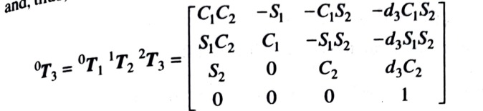

**Inverse Kinematics Equation for 3-DoF**

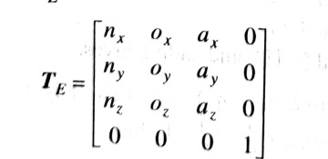

**End Effector Co-ordinate Matrix**

**Circuit Diagrams:**

**Figure 5 Fire Controller Unit**

**Figure 6 Mobility Unit**

1. **Application of proposed Robot in a societal context**

* The proposed firefighting robot offers a safer and more efficient solution for combating fires, reducing the risk to human lives.
* Its application in urban areas and industrial facilities can significantly minimize property damage and environmental impact.
* With its ability to navigate through hazardous environments and accurately target fire sources, this robot can expedite response times, complementing the efforts of firefighters.
* Furthermore, its potential deployment in remote or hard-to-reach areas makes it a valuable asset for protecting communities and natural resources.

1. **Size of Robot proposed for Proof of Concept (Small Version):**
2. Length in cm………30….........
3. Width in cm…………24……….
4. Height in cm…………30……….
5. **Size of Robot proposed as prototype (Actual Version):**
6. Length in cm………60….........
7. Width in cm…………40……….
8. Height in cm………70………….
9. **Timeline for Robot Making with milestones.**
10. **Proof of concept timeline (Total 10 days**)

* 3 days for Chassis Setup and Building
* 2 days for Electronics and Assembly
* 4 days Coding
* 1 day for Testing

1. **Prototype timeline (Total** **18 days)**

* 5 days for Chassis Setup
* 3 days for Electronics Components and Circuitry
* 1 days for Assembly of Parts
* 5 days for Coding
* 1 days for Load and Range Testing
* 3 days for Fire Fighting Testing

1. **Please attach the proposed outline (photography) for understanding of the evaluation committee**.

